Topic 04 – What is a digital image?

Solution 4.1 – How is the image represented by the computer – Pixels

- The pixels become invisible and the image appears to be smoothed. Between two pixels interpolated grey-values are displayed.
- With a regular lookup-table low intensity values are displayed dark and high values bright. With an inverted look low values are displayed bright and high values dark.

Solution 4.2 - How is the image represented by the computer –
In memory image formats

 | count | min | max | mean | stdDev | mode
original | 1339000 | 0 | 255 | 37.223 | 50.755 | 4
+ 100 | 1339000 | 100 | 255 | 136.583 | 49.020 | 104
- 100 | 1339000 | 0 | 155 | 5.576 | 16.285 | 0
× 2 | 1339000 | 0 | 255 | 70.075 | 91.291 | 8
/ 2 | 1339000 | 0 | 128 | 18.839 | 25.393 | 2

  - Since all grey-values have been multiplied by 2, only even values remain in the image except for the value 255, because bigger values have been truncated.
- 4095 = 2¹²-1

- Dividing the image by zero results in all pixels having the value Infinity. Multiplying the result by -1 results in all pixels having the value -Infinity. Dividing the result by Infinity results in all pixels having the value NaN (not a number).
- After dividing by 255 the new maximum in the image is 1. After adding 1e+38 the new maximum is 1e+38. After multiplying by 10 the new maximum is Infinity.
- In the beginning the grey-value histogram of the image is displayed. Pressing the RGB button once switches to the histogram of the red channel, twice to the histogram of the green channel and three times to the histogram of the blue channel.

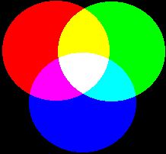Figure 1: Additive color mixing
red and blue = magenta
blue and green = cyan
green and red = yellow
red, green and blue = white

Solution 4.3 - How is the image represented by the computer – Conversion traps
- After converting the intensity is higher in the first image, although it was 10 times less in the original image. When only seeing the converted images one might falsely conclude that the first image contained more more of the tagged protein than the second one.
When converting to 8 bit the values of the image between the smallest and the biggest value in the image are scaled to the range 0 to 255. The range of values in the original image is 297-4095, the range in the multiplied image is 2970-40950.
- Without the scaling values bigger than 255 will become 255. Since all values are bigger than 255 all pixels in the resulting image have the maximum value. After subtracting 297 and converting without scaling the original values 297 to (297+255) will be visible and all values bigger will become 255, saturating the image.
- The pixel 160, 350 has the value 119 without weighted RGB conversion and 134 with. In the first case the rgb-components are added and divided by 3
1/3 * 133 + 1/3 * 146 + 1/3 * 77 = 118.66
In the second case the weights 0.3, 0.59 and 0.11 are used to make the converted image correspond to our visual expectations (red and green are perceived brighter than blue).
0.3 * 133 + 0.59 * 146 + 0.11 * 77 = 134.51

Solution 4.4 - How is the image represented by the computer –
On disc image formats
- The total intensity is 2295 in the original image and 2288 in the jpeg version.

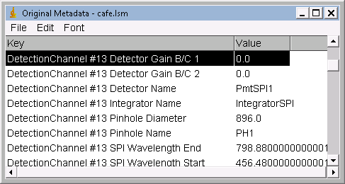Illustration 2: Parts of the metadata imported with the loci-reader.

Solution 4.5 - The image and the real world – sampling and resolution
- The excitation wavelengths of the two channels used (channel #17 and #26) are: 488nm and 543nm. The maximal numerical aperture is 1.4. This gives resolutions of 213nm and 237nm in the two channels. The sampling interval in this case is the voxel size which has the value of 111nm for x and y. According to the Nyquist criterion for the confocal case the pixel size should be equal to or smaller than 44nm.

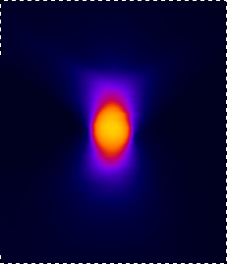Figure 3: The image of a bead in the volume viewer.

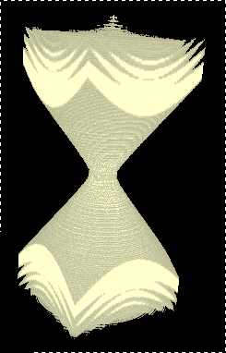Figure 4: A calculated psf displayed in the 3d-viewer.

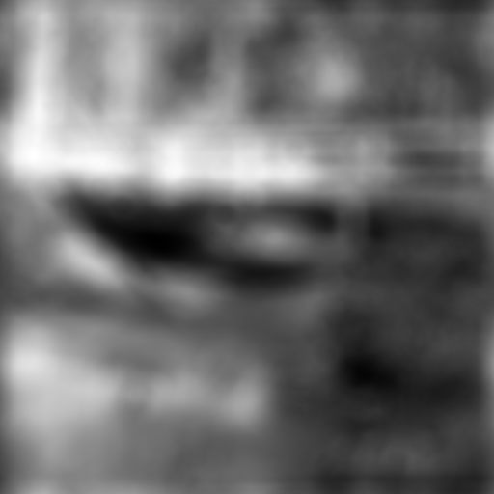Figure 5: The bridge image convolved with the psf.
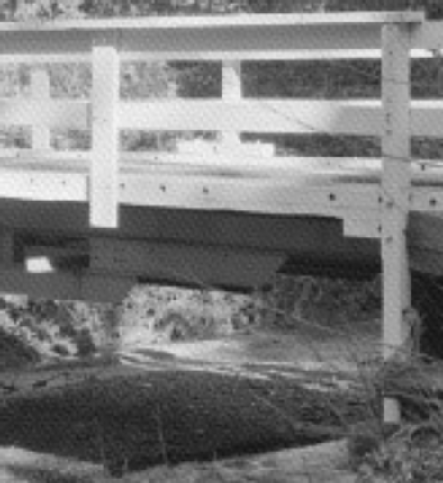Figure 6: The deconvolved image contains some artefacts.

Figure 7: A line as psf.
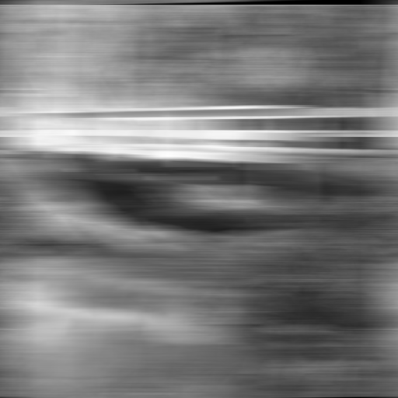Illustration 8: The bridge image convolved with the line psf.
The psf could correspond to a movement of the camera while the image was taken.

Solution 4.6 Image and perception
- The image contains three different colors: (250, 20, 160), (200, 200, 100) and (0, 190, 150). The same color is perceived differently because of the different backgrounds.
- Both are equally bright. The intensity value is 153.
- Both have the same length of about 282 pixels.
- The both have the same size of about 366 pixel.
- It is impossible to automatically segment the white triangle since it does not exist. The triangles in the circles and the parts of the black contour of a triangle make us see the borders of a white triangle, however there is no existing border in the image.

